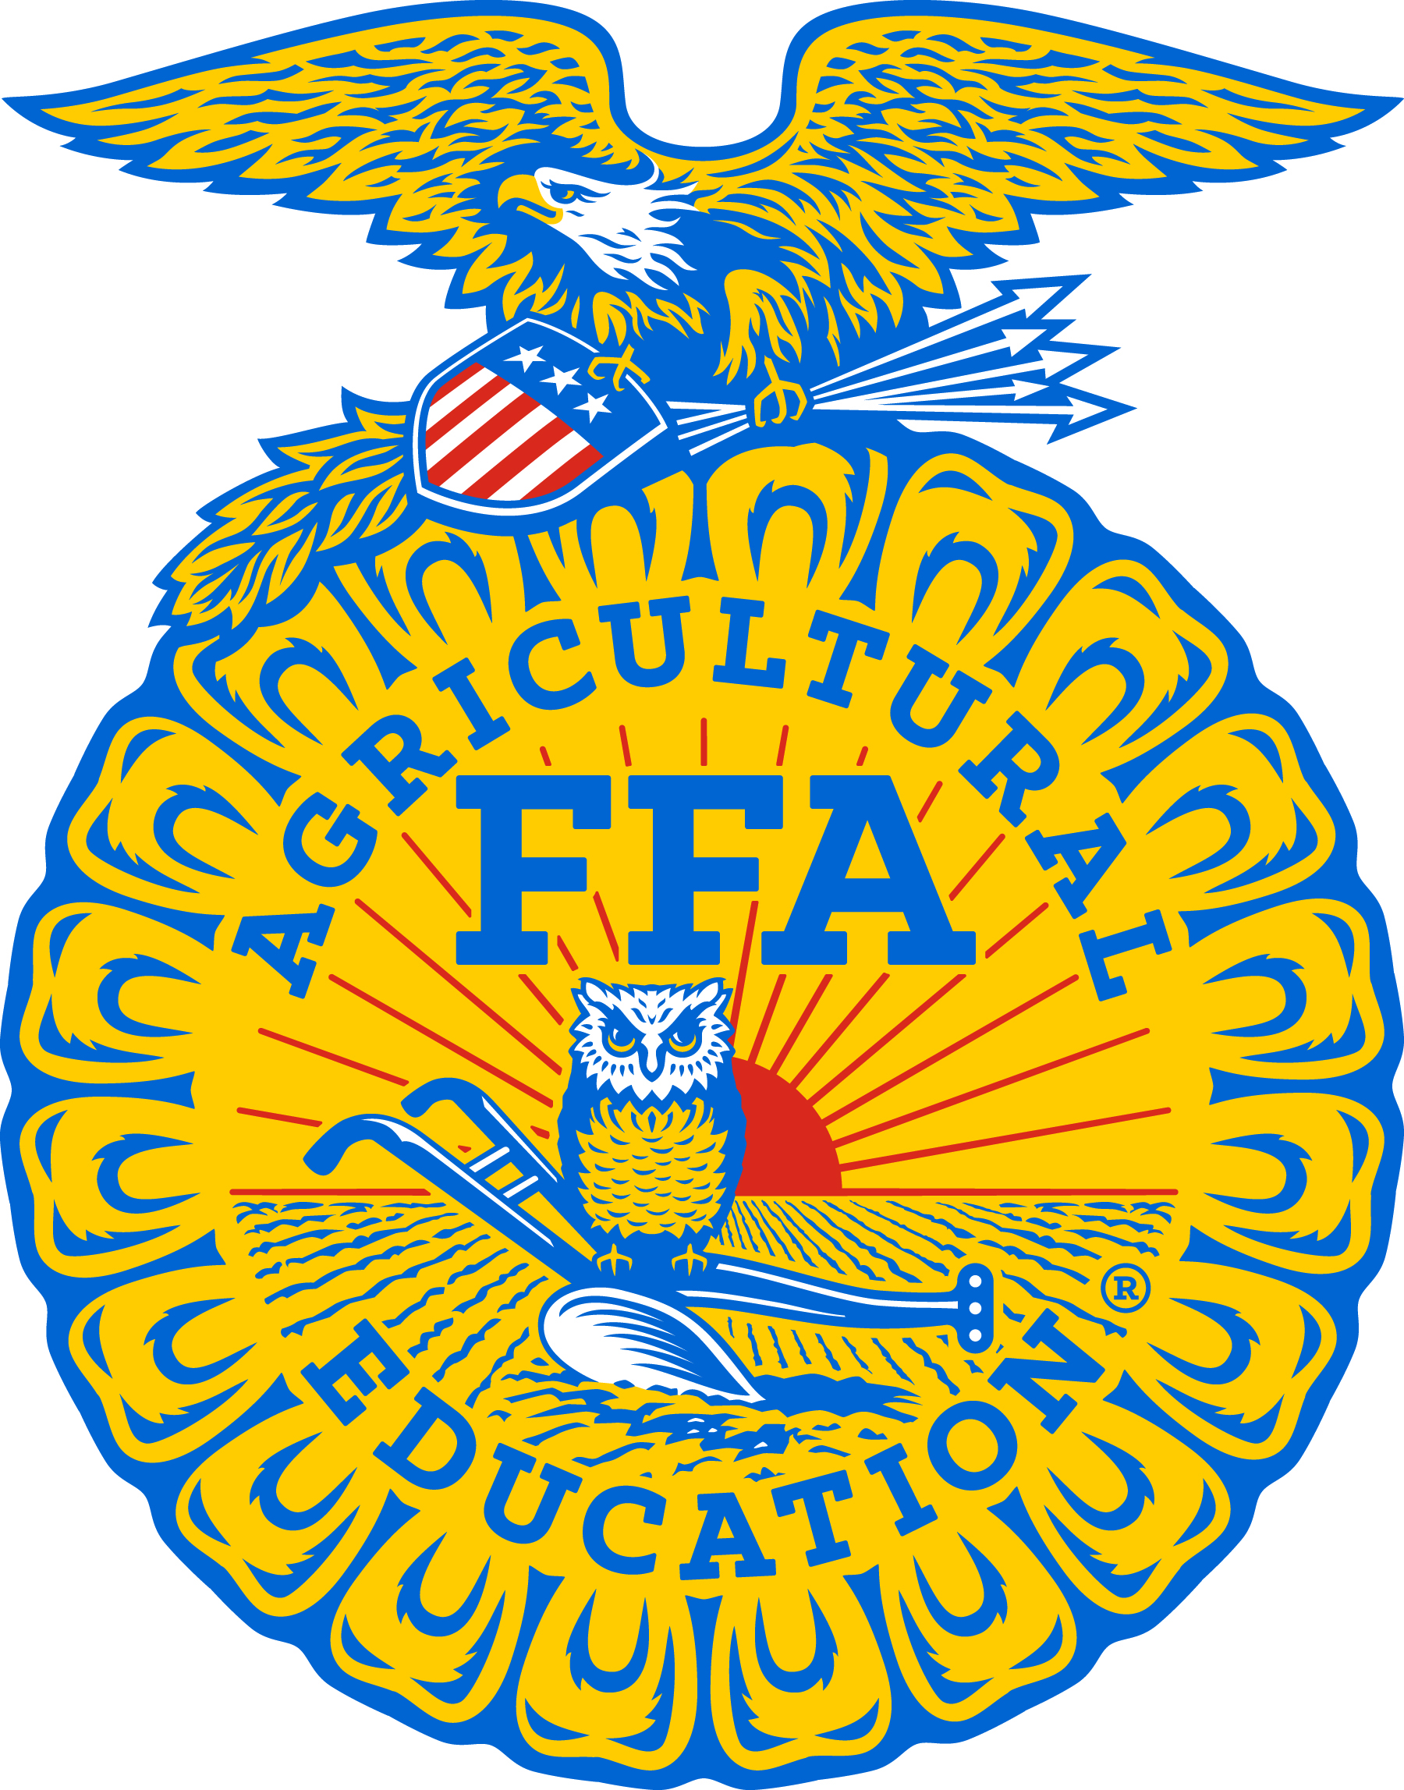
For Immediate Release
Contact: Gerri Ann Eide
Executive Director
SD FFA Foundation
(605) 68765-4865
gerri@sdffafoundation.org
*All photos are available as high-resolution JPG files at: https://drive.google.com/open?id=1HbefWxd3cSlNBfbAwdXh94dMAE_ZK9fe

FFA State Champions Crowned in Career Development Events
BATH, S.D. --- On December 3-4 2017, nearly 600 FFA members from across South Dakota met in Pierre for the State FFA Leadership Career Development Events (CDEs). FFA members and chapters were recognized for their success in 11 leadership areas. Students qualified through district competitions, advancing the top two teams and top three individuals from each of the seven FFA districts. State-winning teams and individuals now advance to the National FFA Career Development Events in Indianapolis next fall.

Parliamentary Procedure teams, consisting of six members per team, demonstrate an FFA business meeting. Our state sponsor is South Dakota Farmers Union. The state level team travel scholarship is sponsored by South Dakota Farmers Union, Monte and Ruth Mason, and Brett and Tracy Kaltvedt. The team results are as follows:
1. McCook Central ((photo left to right) team members Caitlynn McGregor, Ryker Seamer and Natalie Gottlob; back row: Kyle Butzke, Haylee Ecklein, Hadley Stiefvater, Advisors Terry Reickman & Tracy Chase)
2. Lennox-Sundstrom
3. Highmore
4. Menno
5. Willow Lake

The All-State Parliamentary Procedure Team is comprised of the top individual officer from each position in the Parliamentary Procedure CDE. These competitors are the best-of-the-best in their respective position. This area is sponsored by Skinner Financial Services. Those selected are (photo left to right):
President – Cooper Benning, Lennox.
Members At Large:
Jaedyn Oplinger, Menno
Madeline Loewe, Lennox
Natalie Gottlob, McCook Central
Caitlynn McGregor, McCook Central
Veronica Knippling, Highmore

In Prepared Public Speaking, each contestant presents a 6-8 minute agriculture-oriented speech and answers five minutes of related questions. The event and travel scholarship are sponsored by Ag PhD. The results were:
1. Jensina Davis, Brookings
2. Sydney Hoffman, Bridgewater Emery (photo)
3. TJ Bigge, Parkston
4. Danika Gordon, Sturgis
5. Hunter Eide, Gettysburg
6. Heidi Stiklestad, Bowdle
7. Danielle Houghtaling, Doland
8. Journey Mehlhaf, Freeman

In Extemporaneous Public Speaking, an unrehearsed 4-6 minute speech is written and presented onsite. Each contestant is allowed only 30 minutes to prepare. Our state level and travel scholarship sponsor is the South Dakota Farmers Union. Results were as follows (photo left to right 1st -3rd):
1. Bridger Gordon, Sturgis
2. Mitchell VanderWal, Northwestern Area
3. Landen Wolter, Wessington Springs
4. Caleb Wieland, Beresford
5. Sadie VanderWal, Northwestern Area
6. Sam Simenk, Hot Springs
7. Kylee Mogen, Wilmot
8. Sawyer Naasz, Platte-Geddes

Employment Interview Skills challenges FFA members to complete a job application, write a letter of application and resume, participate in an actual interview and compose a follow-up letter. Our sponsor is the South Dakota Department of Agriculture. The winning travel scholarship is sponsored by Kindra Gordon and Three Corners Agency, Inc. – Melissa Stearns, Agent. The results were (photo left to right 1st -2nd with SD Dept of Ag representativeMaggie Stensaas ):
1. Dalton Howe, Redfield
2. Bridger Gordon, Sturgis
3. Blake Kontz, Flandreau
4. Savannah Krogman, Jones County
5. Tiffany Rausch, West Central
6. Madyson Morehart, Winner
7. Jensina Davis, Brookings
8. Marie Robbins, Elkton

Ag Sales team members work together to develop a strategy for selling pre-determined products to specific customer scenarios. Participants also practice their individual sales skills by selling an agricultural product to a customer. This event is sponsored by CHS Brandon. The winning travel scholarship is sponsored by CHS Eastern and Curry Seeds. The results were:
1. West Central ((photo left to right)CHS Brandon Sponsor, Jennifer Johnso,n team members Jacob Harden, Hunter Wilebski, Branzon Underwood, Clay Farmer, advisor Linda Petersen)
2. McCook
3. Rutland
4. Hot Springs
5. Canton

The Junior Conduct of Meetings event is designed for high school freshmen to present a mock FFA meeting. This event is sponsored by Gary Bachman, Prairie Appraisal Service of Bowdle. The team results were:
1. McCook Central ((photo left to right) team members, (back row): Abby Blagg, Jacob Wagner, Kayle Lauck, Lauren Stiefvater, (front row): Paige Peterson, Caitlyn Eich and Madison Stroud, Advisors Terry Reickman & Tracy Chase)
2. Willow Lake
3. Highmore
4. Sturgis
5. Parkston
Creed Speaking participants recite the FFA Creed and answer questions posed by the judges. This event and travel scholarship is sponsored by Craig and Bonnie Dybedahl and Jeremy and Laura Nettifee. The results were:
- Kayle Lauck, McCook Central (photo)
(3rd & 2nd place in separate photo)
2. Tessa Erdman, Groton
3. Kylie Harrimon, Parker
4. Jocelyn Vogel, Mitchell
5. Layton Eide, Deuel
6. Laura Bogue, Beresford
7. Drew Peterson, Garretson
8. Morgan White, Brookings

In Marketing Plan, teams of students determine a local community need and create a complete strategy for marketing a new agricultural product or company to fill that need. The sponsor is Legend Seeds, Inc., and the state winning team travel scholarship is sponsored by Hurley and Associates. The results are:
1. Lennox ((photo left to right) team members Sarah Kroeger, Naomi Reiss, and Brook Geiken, Advisor Jim Wilson)
2. West Central
3. Bowdle
4. Madison
5. McCook Central

In Ag Issues, a team of 3-7 students discuss the pros and cons of a major agricultural issue facing their area. The sponsor is South Dakota Farmers Union and the state winning team travel scholarship is sponsored by by South Dakota Farmers Union and the Farm Forum. The results were:
- Wall ((photo left to right) Back: advisor Dani Herring, team members: Trista Reinert, Karlie Dartt, Cooper McLaughlin; Front: Shelby Ruland, Samantha Deutscher, Brianna Schreiber, Abby Moon)
- Howard
- West Central
- Milbank
- Parker

In Ag Broadcasting/Journalism, students have 30 minutes to prepare a five-minute agricultural radio newscast and then "air" it. This event is sponsored by Ludens Implement. Results were:
- Elle Stiefvater, McCook Central (photo)
- Cassidy Sayler, Vibor-Hurley
- Teanna Pawlowski, Miller (photo)
- Tianna Tschetter, Doland
- Connor Dekker, Philip
- Jessica Colville, Lemmon
- Trevor Johnson, Beresford
- Hunter Peterson, Philip

In Ag Communications, teams of students play the role of communications consultants to develop and present a media plan for an assigned scenario. Members also complete Editing and Communications tests. This event is sponsored by the South Dakota Broadcasters Association. The winning travel scholarship is sponsored by Dakota Farm talk. Results were:
- Northwestern ((photo left to right) Advisor Noelle Swanson, team members Darien Watson, Sadie Vander Wal, Mackenzie Engels, Samantha Olson)
- West Central
- Lemmon
- Miller
- Harrisburg

The South Dakota FFA consists of 90 FFA chapters with nearly 5,000 FFA members. FFA makes a positive difference in the lives of students by developing their potential for premier leadership, personal growth, and career success through agricultural education. Visit http://www.sdffafoundation.org/ for more information, and/or follow us on Facebook (South Dakota FFA Foundation and South Dakota FFA Association).
### -

